**Chapter 1**

**INTRODUCTION**

**1.1 Introduction**

This Online Bus Ticket Booking project deals with an online system designed for booking bus as per the requirements of the customers at their convenience. The current system is manual and it is time-consuming. It is also cost-ineffective, and the average return is low and diminishing .

We give customer satisfaction the utmost priority and so give ample options to book bus ticket by entering details like their journey date and time, origin, pick-up point, destination and the drop-off point they need to reach.

Online bus ticket reservation system is a project which provides a portal for bus ticket reservation. This application allows users to book bus tickets from anywhere and anytime. The user can easily book their tickets and cancel tickets. The user can view all the details of the website, bus, and drive. The user can also view the details of the journey and the details of the journey timings.

This Software project is aimed at automation of online ticket reservation. Objective of the project is to develop customize software package for Ticket booking.

This is the online project works in the website. In this project Passenger books the ticket and he pays through online. This project provides bus details, route information, seats details, billing details , ticket information , seat cancellation , etc.

Online bus ticket booking system project is  implemented as bus ticket reservation system web portal project through which  code and documentation. The documentation will cover the testing of the project once   Online Ticket Sales System 8 Project  can you tell me what problem you facing in bus ticket reservation system project  ended Ticket booking & Generation for Bus  Ticket Reservation.

In our daily life we have to book ticket for Bus, movies, Flight and cricket match or foot boll match. When we do this task manually then it becomes very hard to manage the ticket booking. So are developing this system to manage booking of ticket automatically. In this bus ticket reservation project we develop the system that can help the user to book their ticket online. In this project we take care of every service related to travelling and online ticket booking. When you start your traveling tour you have to book ticket so we help you from the starting point to the end. We help you in booking your traveling ticket.

This project is mainly based on a real life process & has been implemented in the This project is mainly based on a real life process & has been implemented in the Ticket Booking Company **”Ticket reservation System”** is totally based on the system.

**1.2 Project Objective**

The Trans Service Net system is currently maintaining the Transport Company’s process manually which is a very time consuming process. It deals with transport industry’s ticket booking and transport maintenance, so it becomes a very tedious job for the transporter to look after these particulars to complete the task at right time. The Trans Service Net system not only deals with transporters owned vehicles but also takes into consideration about the other types of transport vehicles available with other transporters .

To develop a software application that supports Specific to the Travel Agency Automation that can solve all tedious tasks related to ticket booking in a travel agency.

* The application acts as an office that is open 24/7.
* It is very easy to use.
* This will lead to increase in the efficiency of the Staff and members of the Ticket Booking Agency with little throughput.
* This project is made as user friendly as possible so that any one can use it with little knowledge of computers.
* The project will reduce the tedious job of paperwork by keeping all the details of ticket booking , cancelling tickets are stored in the form database in computer’s hard disk.
* Up-to-date information of the Performance status and other enquires.
* We provide up to date information that is not possible manually.
* The objective of my project is to make easy the system of Ticket Booking Agency simple, reliable, user friendly, and corrective. Moreover less time consuming as compared to manual work.

**1.3 Existing System**

In the existing system, all the booking process and the maintenance of the records is done manually. Users who are interested in inquiring about the bus type, tickets price, available seats, facility of the bus etc. have to walk to the booking office.  This creates a lot of time waste for the users.

The existing system is not user friendly and the user needs to enter all the details of the passenger manually. It consumes lots time and very confusion. Even in the existing system the passenger has to visit the ticket counter to book the ticket .This is not user friendly.

Existing Online Bus Ticket Reservation system requires lots of physical and mental efforts as bus ticket are reserved manually .

The work is done manually. Those who are interested in inquiring about the Bus Type, its Tickets Price, available seats, facility of the bus etc. has to walk to the Booking office. This creates a huge Relief for the Customer of the Office on weekends to save their time.

Many chances of human errors such as wrong entry of journey date, time and location are recorded manually in a register by an employee thereby increasing chances of miss registration.

No clear communication among drivers, passengers and the office leading to a denial of service.  
Punctuality is not maintained and faster accessibility of buss is not possible due to traffic and miscommunication issues.

Level of sharing of information is weak. Customers suffer a lot in terms of comfort and safety. Maintaining and assigning responsibilities to the bus drivers by the service providers becomes difficult in the long run.

Bus Booking System gives bus Booking service for both foreign and local customers. This organization buss out its daily work by providing their service to the customers using manually system. The organization uses a manual system for reserving, renting, register and to keep record of all the Booking activities and customer information.

**1.4 Proposed System**

A new system is helpful to both employees as well as the customers.

New system provides help to the customer as they can inquire about the Bus model, its Ticket price, available Seats, facility of the bus etc. and they don’t need to walk to the office. There is login and password service for employee and Regular customers to use this system .

The proposed Online Bus Booking project system ensures that the users can book the bus as per their requirements by logging on to the website.

It allows users to book their bus online, manage their bookings and cancel their bookings at any point of time.

The users will get notified about the driver and his mobile no. so as to communicate with him.  
Regular updates are provided to the customer so that they are aware of their bookings, driver details, and booking status. The user can also drop in their suggestions or queries in the feedback form.

**1.5 Modules**

**1.5.1 Login** **module** **:**

Login Module includes various utilities like User Authentication, Change Password and Forgot Password To access this Online Reservation System, each user should have a valid login id and password. After providing the correct login id and password, users will able to access the main system.

**1.5.2 Reservation System :**

Under reservation form users will have to fill the necessary details such as their basic details, train number, train name will automatically come in the box, class type, date of journey, from (place) to destination and after that, users will have to press insert button.

In this website provide a some facility user can Registered in this website. user can use this facility so user can make a registration.

**1.5.3 Book the Ticket :**

In this module admin can add new bus category using this module. Bus Category contains like Volvo, Slipper coach, Ac Coach etc.

**1.5.4 Cancel the Booking Ticket :**

When an issued ticket needs to be cancelled, the agent can log in to the website, and enter the number of the ticket for cancellation. In order to ensure that no ticket is cancelled except by the holder or under his permission, cancellation will require entry of a hidden number that is printed beneath the serial number on the left bottom corner of the ticket

which will be revealed on scratching of the surface. The scratching will also ensure that

the cancelled ticket cannot be re-issued. If users want to confirm their cancellation, in this case they have to press OK button.

**1.5.5 Update Bus Information :**

In this module admin can add or Update Bus using this module. It contains the information about the Bus type , photo,description, Location of tour, Available Seats in Bus etc.In this Module User can Cancel the booking Ticket.

**1.6 Advantages:**

* This time people search for easily availability of things so through that you can book ticket from home , you have to go no were for searching bus and its reservation.
* you can easily find out in which type of bus you want to travel seating or sleeper bus or AC.
* you can see how many seats are available and what are there places according to that you can book your seats.
* you can select your boarding place from there bus can pic you up.

**Chapter 2**

**REQUIERMENT GATHERING**

**2.1 User Interfaces:**

The user interface for this system will have to be simple and clear. Most importantly, the ages must be easy to read, easy to understand and accessible. The color scheme should be appropriate to provide familiarity with the Company and there should be no contrast issues. After being authenticated by correct username and password, user will be redirect to their corresponding profile where they can do various activities. The user interface will be simple and consistence, using terminology commonly understood by intended users of the system. The system will have simple interface, consistence with standard interface, to eliminate need for user training of infrequent users.

The requirement definition is concerned with the analysis of the existing system with the aim of determining and structuring the requirement of the proposed system. It is achieved with the aid of user requirement.

**2.2 Hardware Requirement :**

* PROCESSOR :- 1.6 GHz
* RAM :- 1 GB
* HARD DISK :- Minimum 20GB

**2.3 Software Requirement :**

* OPERATING SYSTEM :-Window 8/10 or other equivalent
* LANGUAGE USED :- PHP, HTML, CSS, JAVA SCRIPT
* DATA BASE :- MYSQL

**2.4 Non-functional Requirements:**

Non-functional requirements, as the name suggests, are requirements that are not directly concerned with the specific services delivered by the system to its users. They may relate to emergent system properties such as reliability, response time, and store occupancy. Alternatively, they may define constraints on the system implementation such as the capabilities of I/O devices or the data representations used in interfaces with other systems. Non-functional requirements, such as performance, security, or availability, usually specify or constrain characteristics of the system as a whole.

Non-functional requirements address aspects of the system other than the specific functions it performs. These aspects include system performance, costs, and such general system characteristics as reliability, security, and portability. The non-functional requirements also address aspects of the system development process and operational personnel.

**2.4.1 Usability:**

The system provides a help and support menu in all interfaces for the user to interact with the system. The user can use the system by reading help and support.

**2.4.2 Security:**

The system provides username and password to prevent the system from unauthorized access. The staffs’ password must be greater than eight characters. The subsystem should provide a high level of security and integrity of the data held by the system, only authorized personnel of the company can gain access to the company’s secured page on the system; and only users with valid password and username can login to view user’s page.

**2.4.3 Performance:**

The system response time for every instruction conducted by the user must not exceed more than a minimum of 10 seconds. The system should have high performance rate when executing user’s input and should be able to provide response within a short time span usually 50 second for highly complicated task and 20 to 25 seconds for less complicated task.

**2.4.4 Availability:**

The system should always be available for access at 24 hours, 7 days a week. Also in the occurrence of any major system malfunctioning, the system should be available in 1 to 2 working days, so that business process is not severely affected.

**2.4.5 Error handling:**

Error should be considerably minimized and an appropriate error message that guides the user to recover from an error should be provided. Validation of user’s input is highly essential. Also the standard time taken to recover from an error should be 15 to 20 seconds.

**2.4.6 Ease of use:**

Considered the level of knowledge possessed by the users of this system, a simple but quality user interface should be developed to make it easy to understand and required less training.

**2.5 Security Requirements:**

Some of the factors that are identified to protect the software from accidental or malicious access, use, modification, destruction, or disclosure are described below. Specific requirements in this area could include the need to:

* Utilize certain cryptographic techniques.
* Keep specific log or history data sets.
* Assign certain functions to different modules.
* Restrict communications between some areas of the program.
* Check data integrity for critical variables.
* Later version of the software will incorporate encryption techniques in the user/license authentication process.
* The software will include an error tracking log that will help the user understand what error occurred when the application crashed along with suggestions on how to prevent the error from occurring again.

**2.6 Functional Requirements:**

Functional requirements define the specific functions that the system performs, along with the data operated on by the functions. The functional requirements are presented in scenarios that depict an operational system from the perspective of its end users. Included are one or more examples of all system features and an enumeration of all the specific requirements associated with these features.

* The system shall incorporate mechanism to authenticate its users.
* The system shall verify and validate all user input and should notify in case of error detection and should help the user in error correction.
* The system shall allow sharing of files in the system.
* The system shall allow quick messages to be exchanged without face to face interaction.

**Chapter 3**

**FEASIBILITY STUDY**

**3.1 Feasibility study:**

Feasibility study is a high level capsule version of the entire system analysis and design process. The objective is to determine quickly at a minimum expense how to solve a problem. The purpose of feasibility is not to solve the problem but to determine if the problem is worth solving.

The feasibility study of any system is mainly intended to study and analyze the proposed system and to decide whether the system under consideration will be viable or not after implementation. That is it determines the usability of the project after deployment. To come to result a set of query is answered keeping the efficiency of the software and its impact on the domain for which it was developed. It main emphasis is on the following three questions elucidated below as:

What are the user’s requirements and how does a candidate system meet them?

What resources are available for the proposed systems? Is it worth solving the problem?

What is the likely impact of the proposed system on the organization? I.e. how does the proposed system fit with in the organization?

Thus since the feasibility study may lead to commitment of large resources, it becomes necessary that it should be conducted competently and no fundamental errors of judgment are made.

The system has been tested for feasibility in the following points.

**3.1.1 Technical Feasibility:**

The project entitles "Bus Booking System” is technically feasibility because of the below mentioned feature. The project was developed in Java which Graphical User Interface. It provides the high level of reliability, availability and compatibility. All these make HTML, CSS, PHP an appropriate language for this project. Thus the existing software HTML,CSS,PHP is a powerful language.

In technical feasibility, we study all technical issues regarding the proposed system. It is mainly concerned with the specifications of the equipment and the software, which successfully satisfies the end-user’s requirement. The technical needs of the system may vary accordingly but include:

* The feasibility to produce outputs in a given time.
* Response time under certain conditions.
* Ability to process a certain volume of the transaction at a particular speed.
* Facility to communicate data.

**3.1.2 Economical Feasibility:**

The computerized system will help in automate the selection leading the profits and details of the organization. With this software, the machine and manpower utilization are expected to go up by 80-90% approximately. The costs incurred of not creating the system are set to be great, because precious time can be wanted by manually.

Economic feasibility is the most frequently used technique for evaluating the effectiveness of the proposed system. More commonly known as cost/benefit analysis, the procedure is to determine the benefits and savings that are expected from the proposed system and compare them with the costs. If the benefits outweigh costs, a decision is taken to design and implement the system otherwise further justification or the alternative in the proposed system will have to be made if it is to have a chance of being approved. This outgoing effort improves in accuracy at each phase of the system development life cycle.

**3.1.3 Operational Feasibility:**

This measures how well your company will be able to solve problems and take advantage of opportunities that are presented during the course of the project. Operational feasibility covers two aspects. One is technical performance and other is acceptance by users. The system is operationally feasible as it is user interactive and user friendly. It fulfills all the user’s requirements.

Proposed projects are beneficial only if they can be turned into information system that will meet the operating requirements for which they are designed and developed. It is mainly related to human organizational and political aspects. People are resistant to change , and computers have been known to facilitate change. Findings of operational feasibility analysis can be summarized as given below:

* Since the audiences are million of citizen who use it for information retrieval. So their will be many who will be benefited with this project
* End users are always welcome to have the technical support on the site.

**Chapter 4**

**SYSTEM ANALYSIS**

**4.1 USE CASE DIAGRAM (ADMIN)**

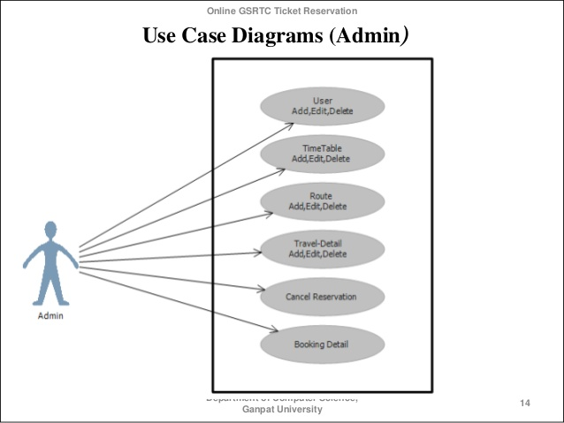

Figure 3.1.1 : use case diagram (admin)

**4.2 USE CASE DIAGRAM (CUSTOMER)**

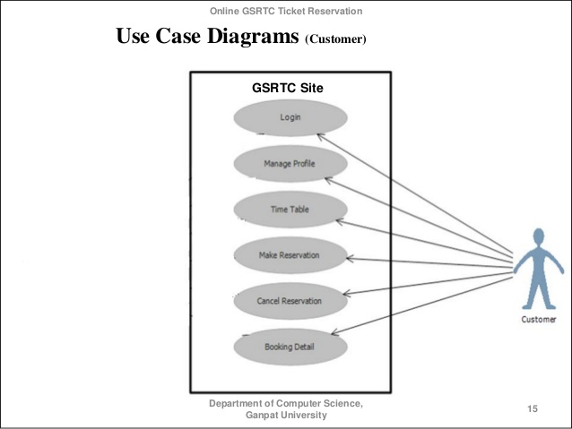

Figure 3.1.2 :use case diagram (customer)

**4.3 ACTIVITY DIAGRAM (ADMIN)**

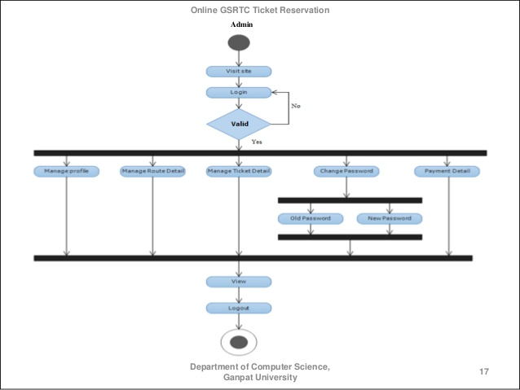

Figure 3.1.3 : activity diagram (admin)

**4.4 ACTIVITY DIAGRAM (CUSTOMER)**

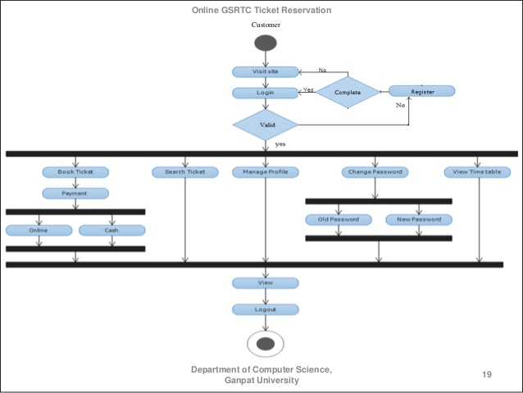

Figure 3.1.4 : activity diagram (customer)

**4.5 USE CASE DIAGRAM**

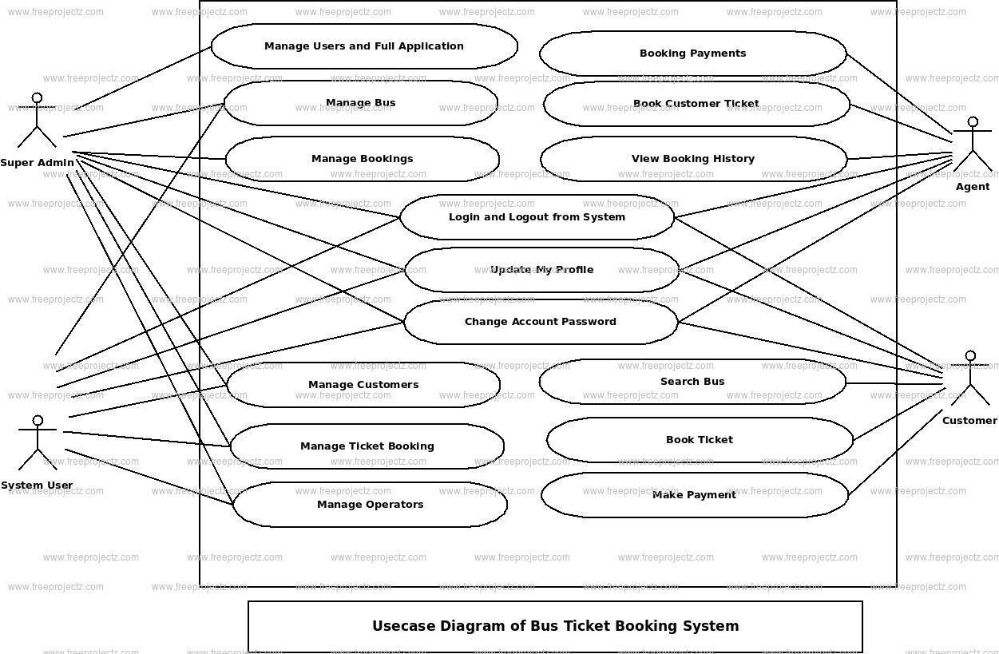

Figure 3.1.5: use case diagram

**4.6 ER- DIAGRAM**

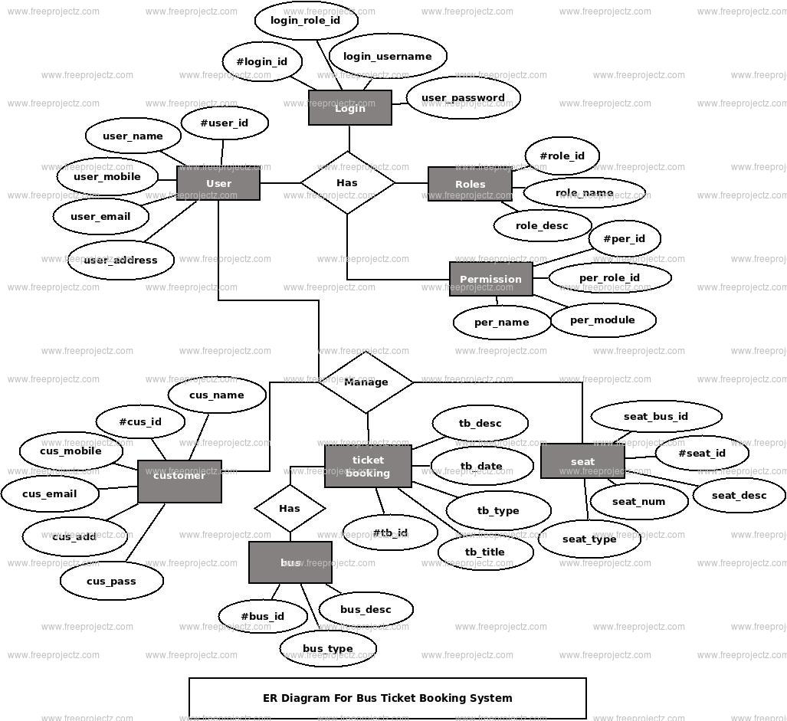

Figure 3.1.6 : E-R- diagram

**4.7 STATE DIAGRAM**

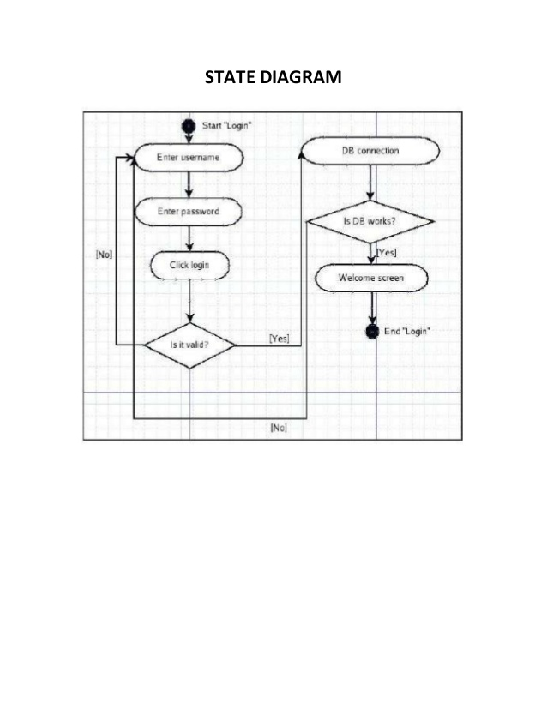

Figure 3.1.7 :state diagram

**4.8 DFD DIAGRAM**

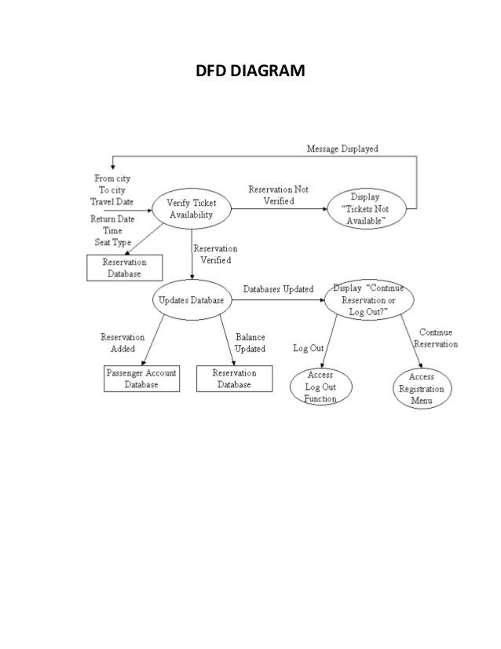

Figure 3.1.8 :DFA diagram

**4.9 CLASS DIAGRAM**

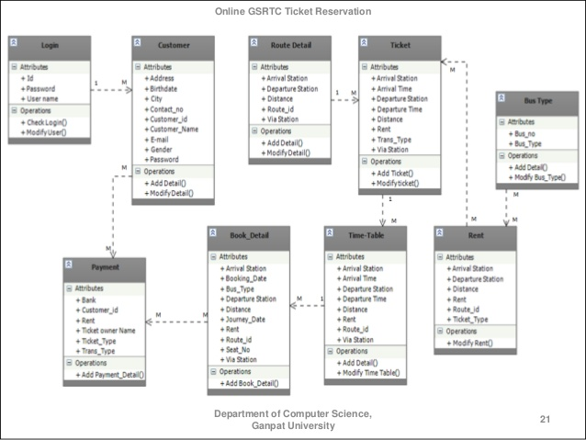

Figure 3.1.9 : class diagram

**4.10 SEQUENCE DIAGRAM (ADMIN)**

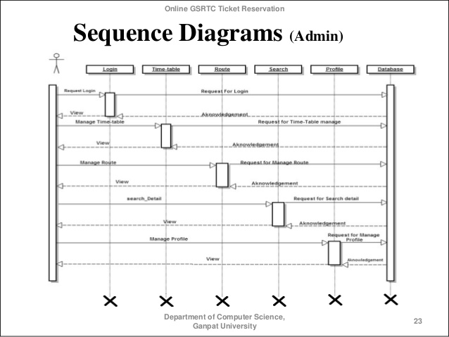

Figure 3.1.10 :sequence diagram (admin)

**4.11 SEQUENCE DIAGRAM (CUSTOMER)**

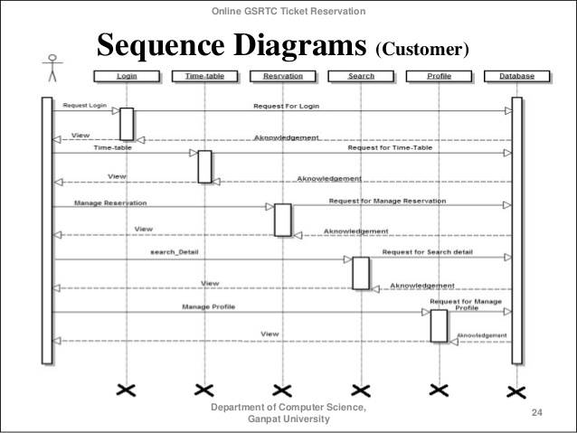

Figure 3.1.11: sequence diagram (customer)

**Chapter 5**

**SYSTEM DESIGN**

**5.1 HOME PAGE**

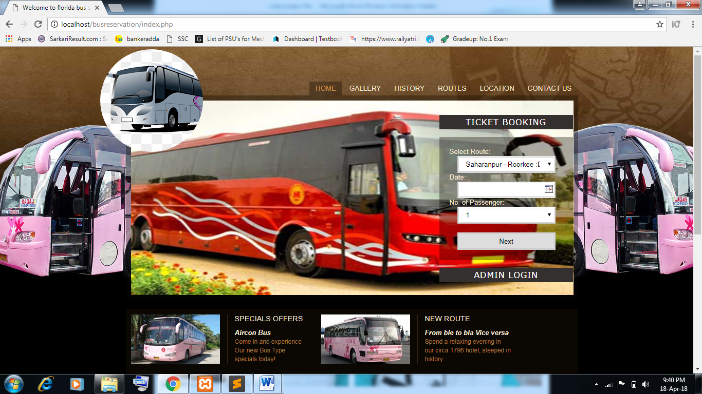

**5.2 GALLERY**

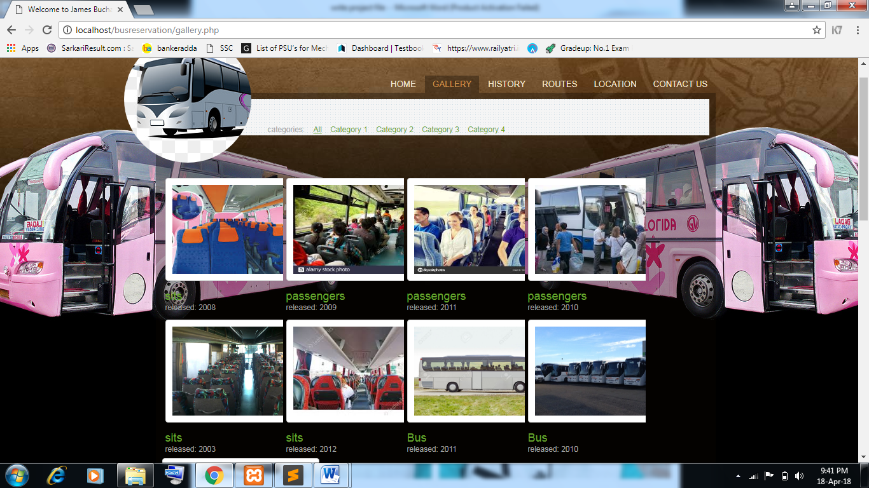

**5.3 TICKET BOOKING**

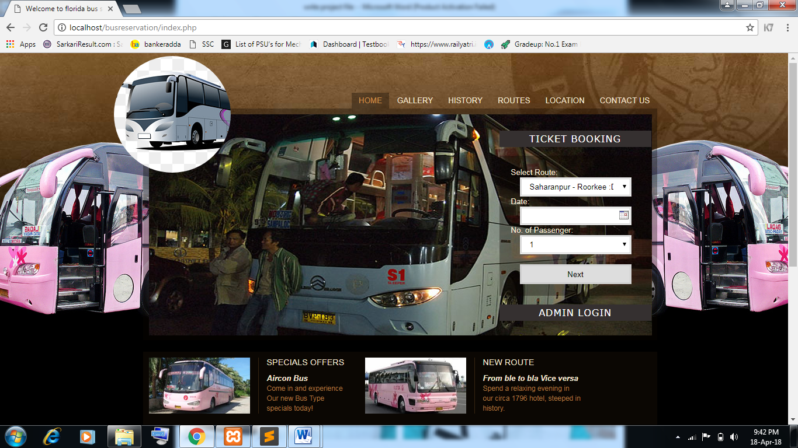

**5.4 REGISTRATION FROM**

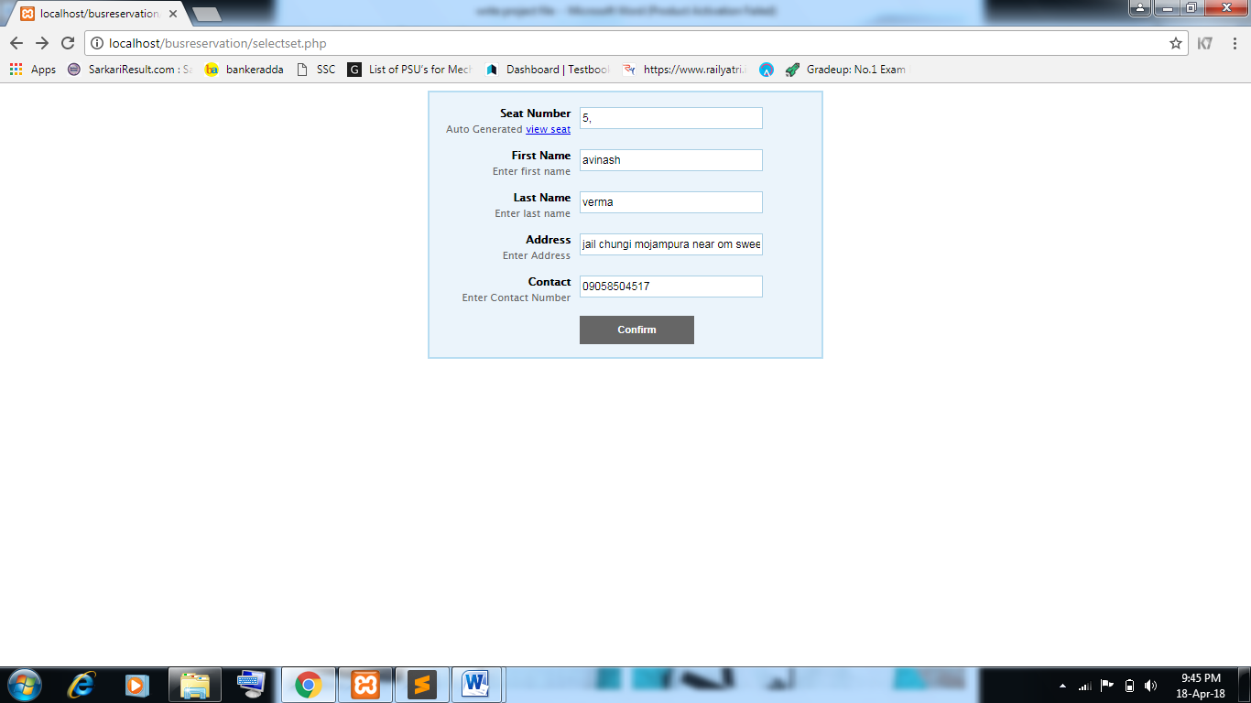

**5.5 TICKET RESERVE DETAIL**

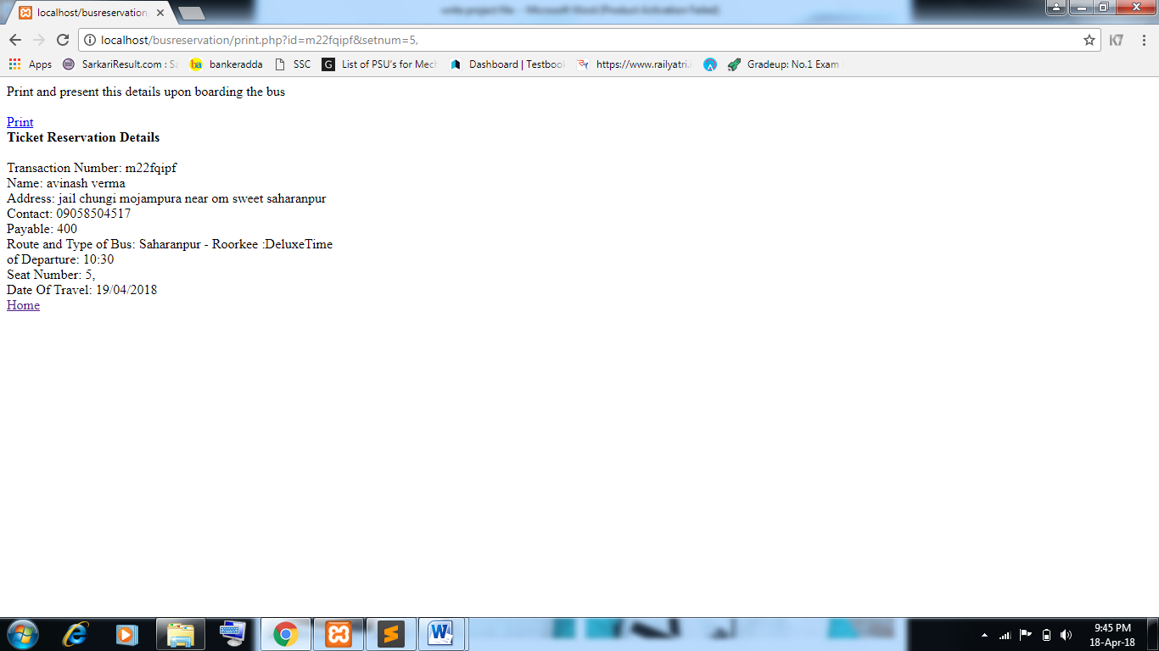

**5.6 ADMIN LOGIN**

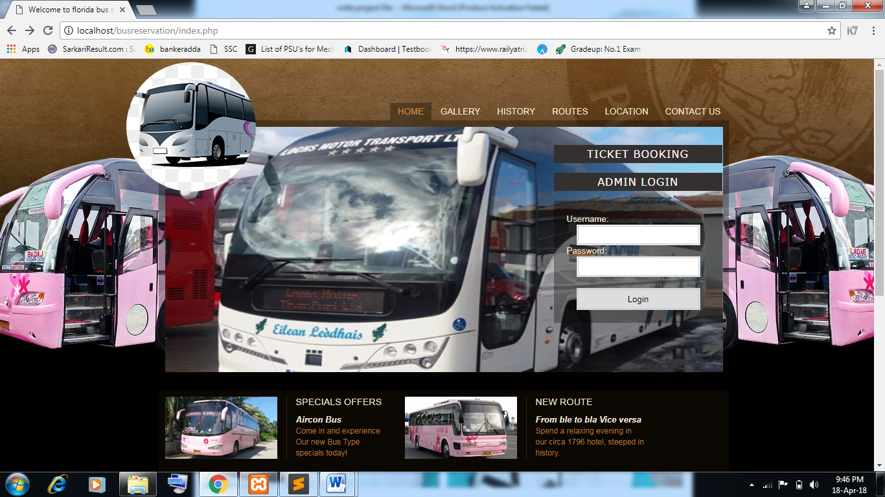

**5.7 CUSTOMER DETAIL**

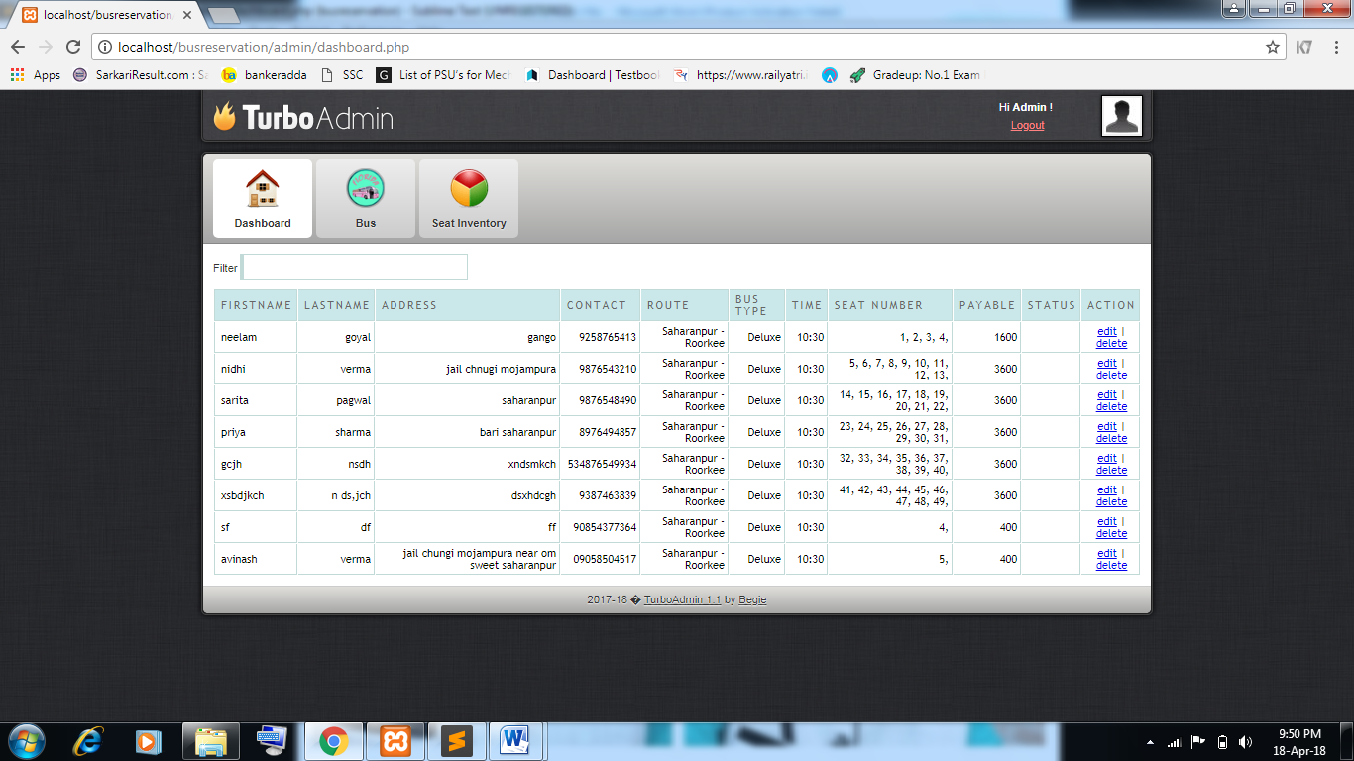

**5.8 BUS DETAIL**

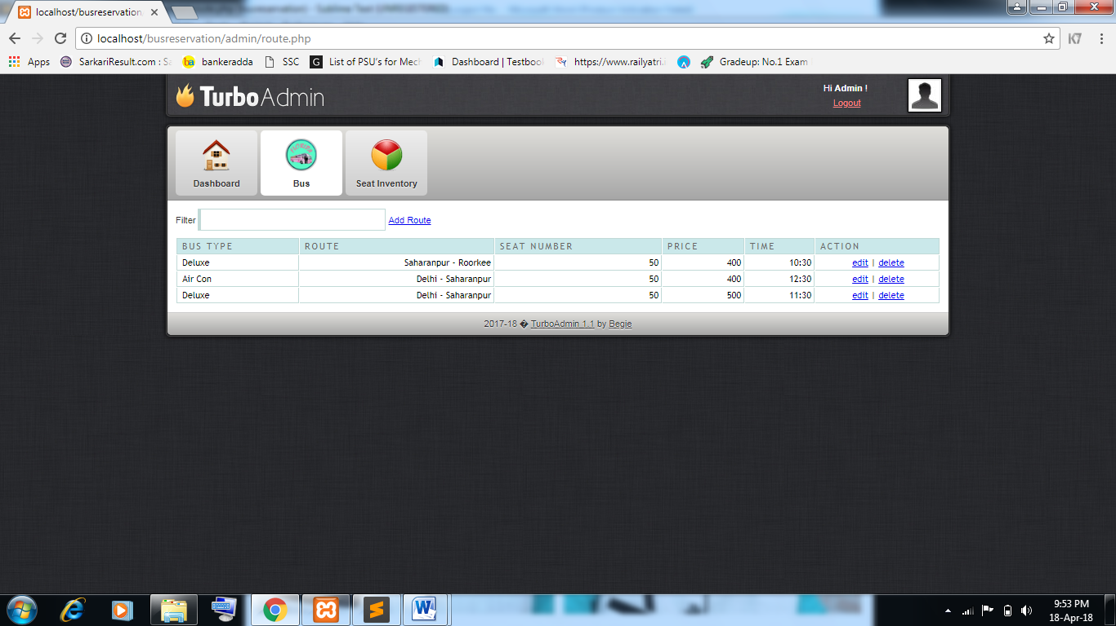

**5.9 ADD BUS DETAIL**

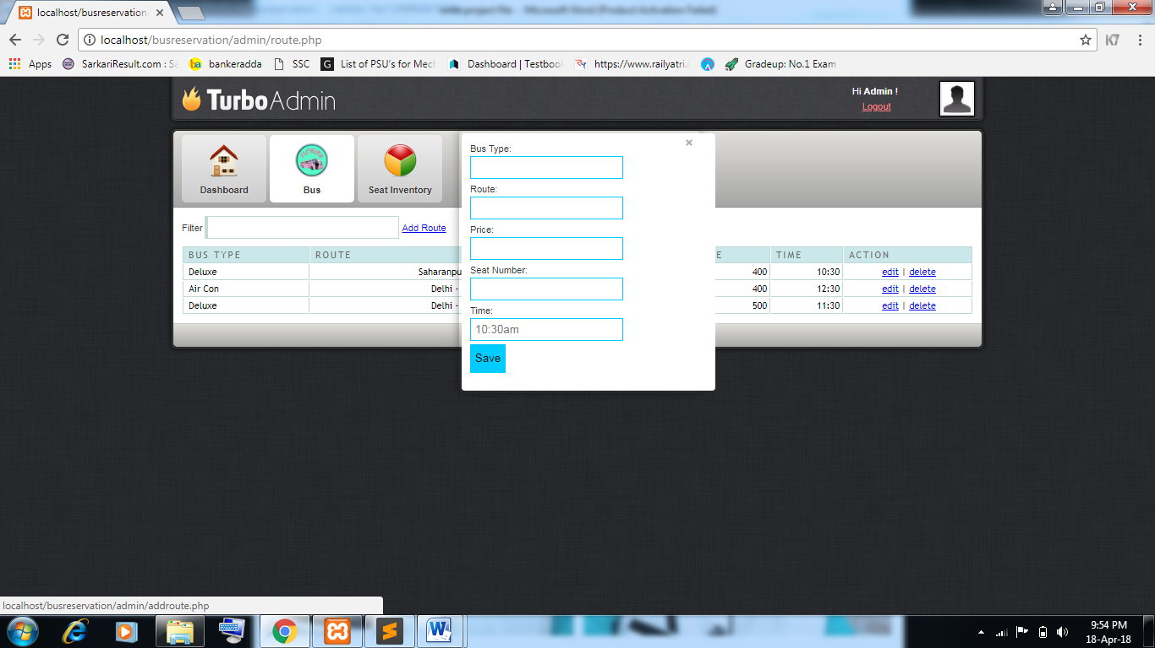

**5.10 SEAT DETAIL**

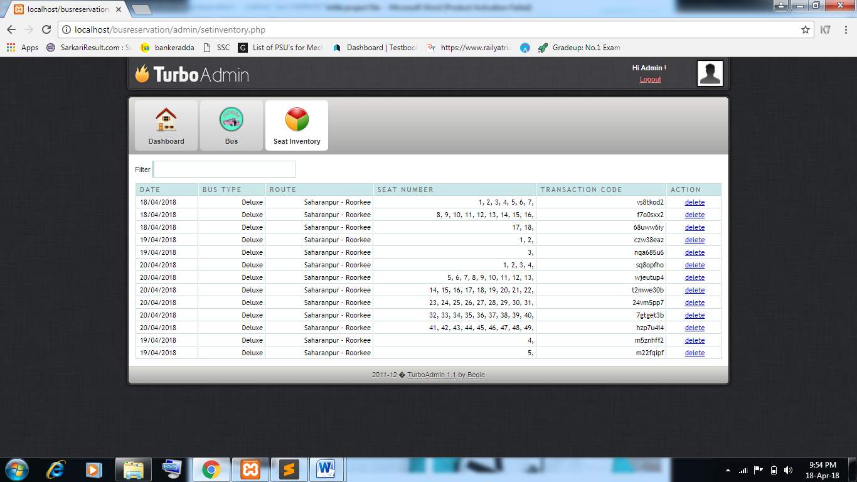

**5.11 ROUTES DETAIL**

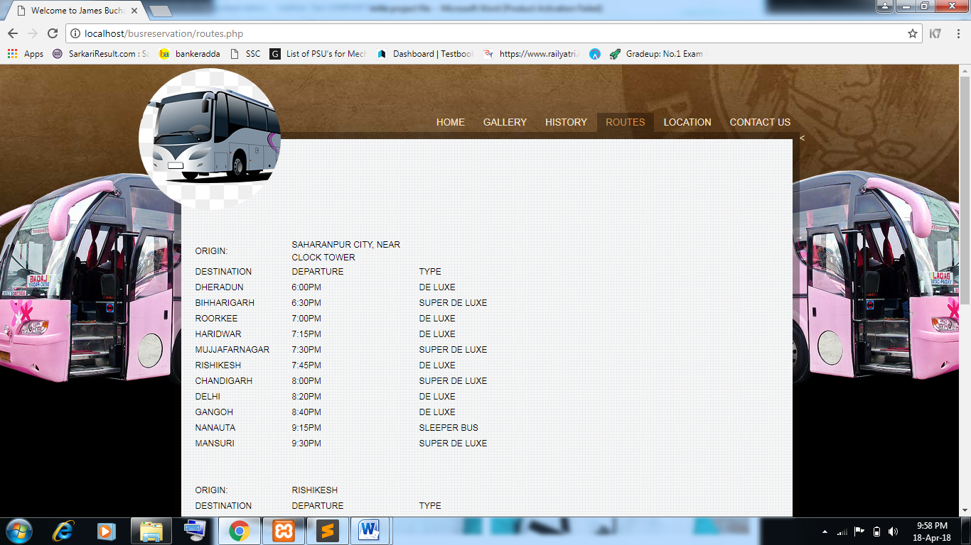

**5.12 ROUTES MAP**

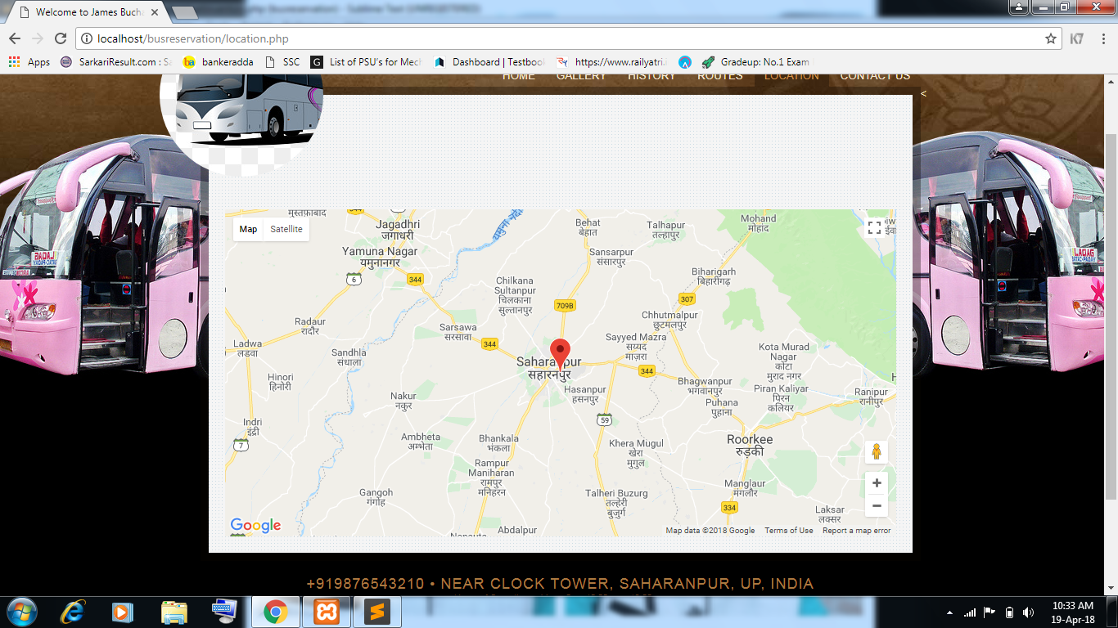

**5.13 CONTACTS**

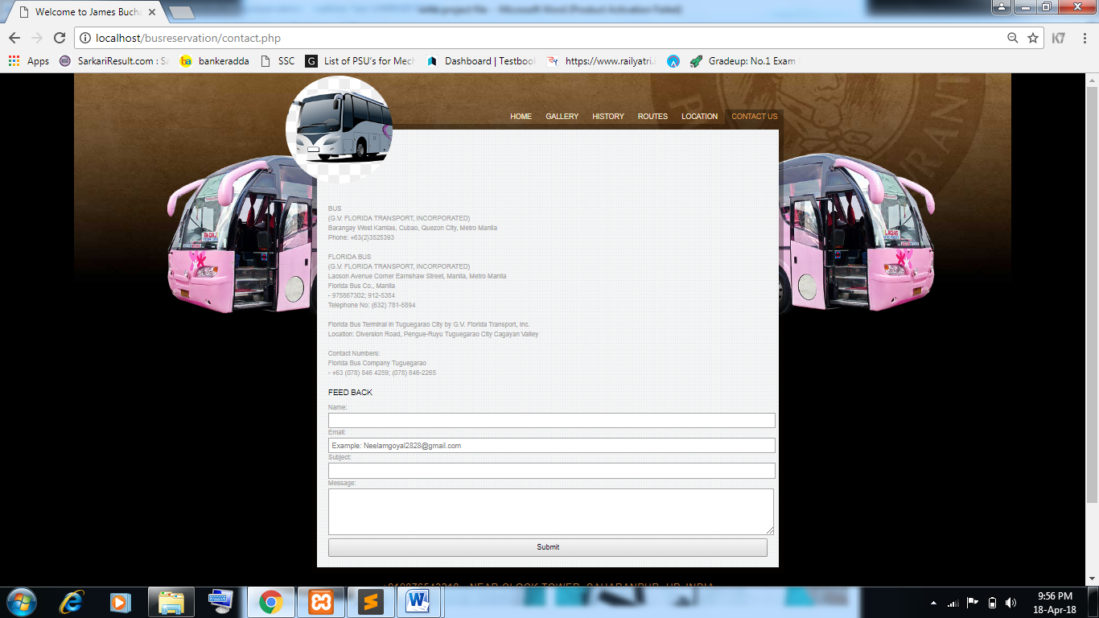

**Chapter 6**

**CODING**

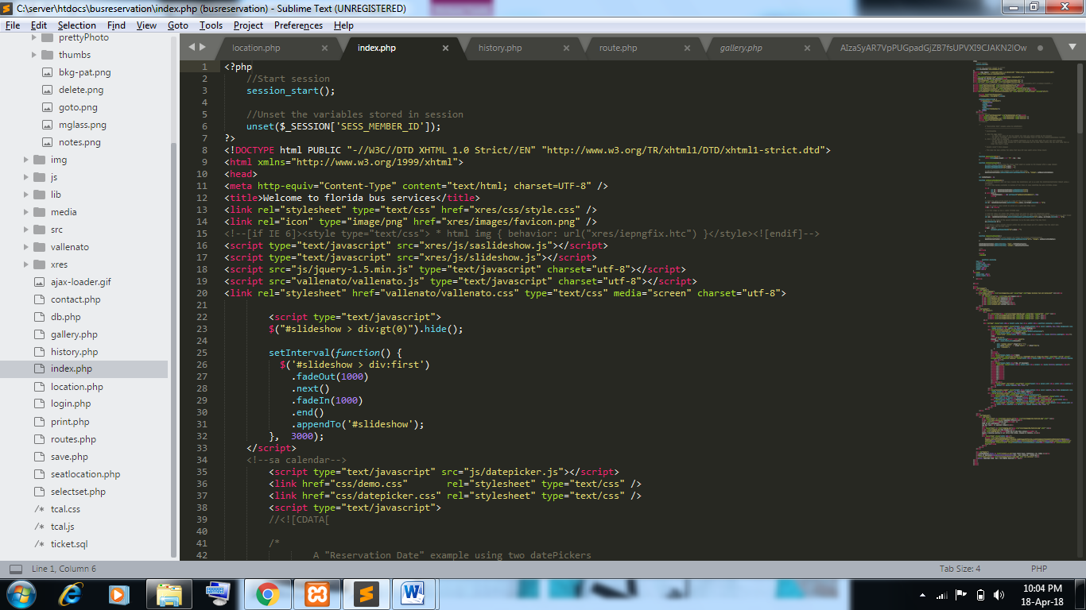

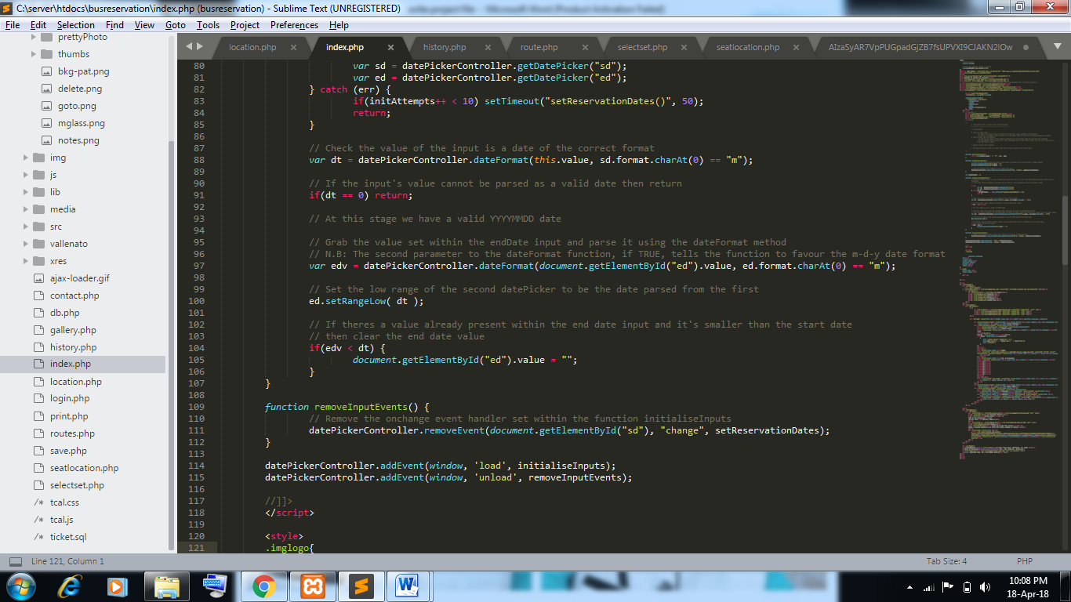

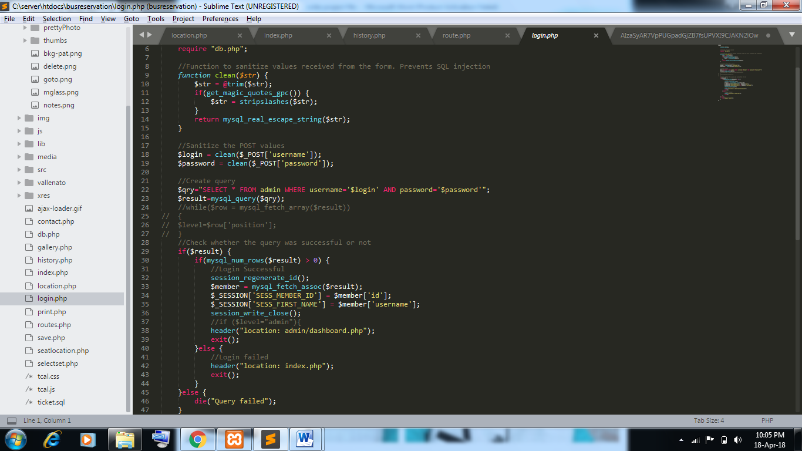

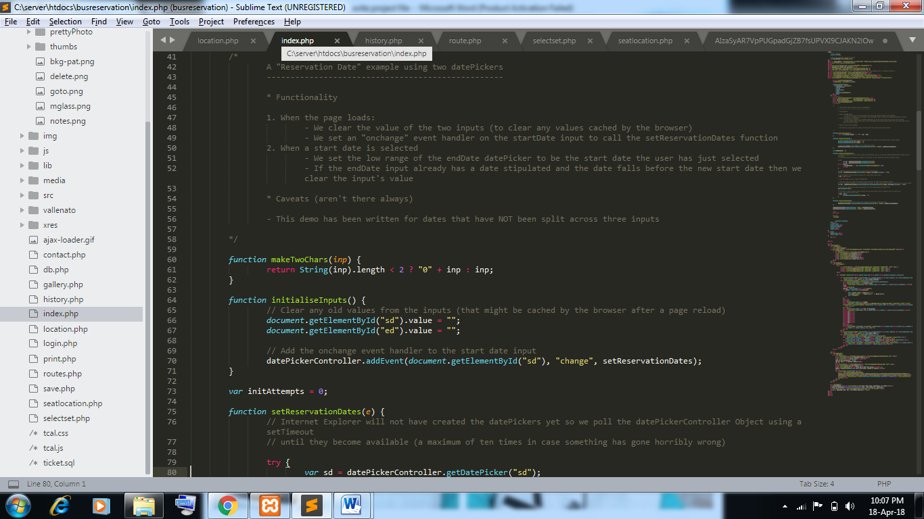



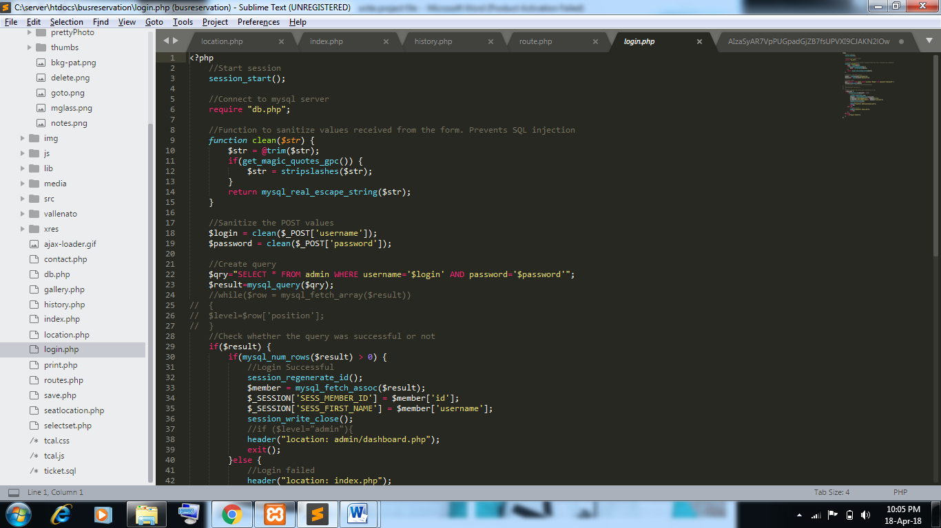

**Chapter 7**

**TESTING**

**7.1 Testing**

Testing is the process of evaluating a system or its component with the intent to find whether it satisfies the specified requirements or not. Testing is executing a system in order to identify any gaps, errors, or missing requirements in contrary to the actual requirements.

A process of analyzing a software item to detect the differences between existing and required conditions (that is defects/errors/bugs) and to evaluate the features of the software item.

**7.1.1 Acceptance Testing:**

This is arguably the most important type of testing, as it is conducted by the Quality Assurance Team who will gauge whether the application meets the intended specifications and satisfies the client’s requirement.

The QA team will have a set of prewritten scenarios and test cases that will be used to test the application. More ideas will be shared about the application and more tests can be performed on it to gauge its accuracy and the reasons why the project was initiated.

Acceptance tests are not only intended to point out simple spelling mistakes, cosmetic errors, or interface gaps, but also to point out any bugs in the application that will result in system crashes or major errors in the application. By performing acceptance tests on an application, the testing team will deduce how the application will perform in production. There are also legal and contractual requirements for acceptance of the system.

**7.1.2 System Testing:**

System Testing is the testing of a complete and fully integrated software product.

Usually software is only one element of a larger computer based system. Ultimately, software is interfaced with other software/hardware systems.

System Testing is actually a series of different tests whose sole purpose is to exercise the full computer based system.

System testing tests the system as a whole. Once all the components are integrated, the application as a whole is tested rigorously to see that it meets the specified Quality Standards. This type of testing is performed by a specialized testing team. System testing is important because of the following reasons:

• System testing is the first step in the Software Development Life Cycle, where the application is tested as a whole.

• The application is tested thoroughly to verify that it meets the functional and technical specifications.

• The application is tested in an environment that is very close to the production environment where the application will be deployed.

• System testing enables us to test, verify, and validate both the business requirements as well as the application architecture.

System testing is actually a series different test whose primary purpose is to full exercise the computer base system .Where the software and other system elements are tested as whole .To test computer software , we spiral out along streamlines that broadens the scope of testing with each turn. The last higher-order testing step falls outside the boundry of software Engineering and in to the broader context of computer system engineering. Software, once validated, must be combining with order system Elements (e.g. hardware , people, databases).System testing verifies that all the elements Mesh properly and that overall system function/performance is achieved.

a.. Recovery Testing

b. Security Testing

c. Stress Testing

**7.1.3 Integration testing:**

Integration testing implements a module code for a system and tests if it works correctly or not. And if error occurs and we can solve it.

Integration testing is defined as the testing of combined parts of an application to determine if they function correctly. In a comprehensive software development environment, bottom-up testing is usually done first, followed by top-down testing. The process concludes with multiple tests of the complete application, preferably in scenarios designed to mimic actual situations.

Integration testing is a system technique for constructing the program structure while at the same time conducting tests to uncover errors associated with interfacing. The objective is to take unit tested modules and build a program structure that has been dictated by design. Bottom-up integration is the traditional strategy used to integrate the components of a software system into functioning whole. Bottom-up integration consists of unit test followed by testing of the entire system. A sub-system consists of several modules that communicated with other defined interface.

The system was done the integration testing. All the modules were tested for their compatibility with other modules .They test was almost successful. All the modules

Coexisted very well, with almost no bugs. All the modules were encapsulated very well so as to not hamper the execution of other modules.

Integration testing can be done in two ways: Bottom-up integration testing and Top-down integration testing.

**7.1.3.1 Bottom-up integration:**

This testing begins with unit testing, followed by tests of progressively higher level combinations of units called modules or builds.

**7.1.3.2 Top-down integration:**

In this testing, the highest-level modules are tested first and progressively, lower-level modules are tested thereafter.

**7.1.4 Unit Testing:**

Unit testing in which we have created one by one module and tested a module unit wise and find a error and solve this error. This type of testing is performed by developers before the setup is handed over to the testing team to formally execute the test cases. Unit testing is performed by the respective developers on the individual units of source code assigned areas. The goal of unit testing is to isolate each of the program and show that individual parts are correct in terms of requirements and functionality.

Unit test comprises of a set tests performed by an individual program prior to the integration of the unit into large system. A program unit is usually the smallest free functioning part of the whole system. Module unit testing should be as exhaustive as possible to ensure that each representation handled by each module has been tested. All the units that makeup the system must be tested independently to ensure that they work as required.

During unit testing some errors were raised and all of them were rectified and handled well. The result was quiet satisfactory and it worked well.

This is the testing process which we can do manually because in this testing program is a tested individually using dummy record to see whether that program produce satisfied output as the company and validation also.

#### 7.1.5 Validation Testing :

After validation testing, software is completely assembled as a package, interfacing errors that have been uncovered and corrected and the final series of software test; the validation test begins. Steps taken during software design and testing can greatly improve the probability of successful integration in the larger system. System testing is actually a series of different tests whose primary purpose is to fully exercise the compute –based system.

**Chapter 8**

**IMPLEMENTATION**

The purpose of System Implementation can be summarized as follows: It makes the new system available to a prepared set of users and positioning on-going support and maintenance of the system within the performing organization. At a finer level of detail, deploying the system consists of executing all steps necessary to educate the Consumers on the use of the new system, placing the newly developed system into production, confirming that all data required at the start of operation is available and accurate, and validating that business function that interact with the system are functioning properly. Transitioning the system support responsibility involves changing from a system development to a system support and maintenance mode of operation, with ownership of the new system moving from the project team to the performing organization. System implementation is the important stage of project when the theoretical design is tuned into practical system. The main stages in the implementation are as follow:

• Planning

• Training

• System testing and

• Changeover Planning

Planning is the first task in the system implementation. Planning means deciding on the method and the time scale to be adopted. At the time of implementation of any system people from different departments and system analysis involve. They are confirmed to practical problem of controlling various activities of people outside their own data processing departments. The line managers controlled through an implementation coordinating committee.

The committee considers ideas, problems and complaints of user department, it must also consider:

• The implementation of system environment.

• Self selection and allocation from implementation tasks.

• Consultation with unions and resources available.

• Standby facilities and channels of communication.

Because of these and other impacts, the communication of planned deployment activities to all parties involved in the project is critical. A smooth deployment requires strong leadership, planning and communications.

**Chapter 9**

**FUTURE ENHANCEMENT**

Every system should allow scope for further development or enhancement. The system is developed to incorporate all the current requirements in future, the system can be enhanced to provide more functionality.

In Online Bus Ticket Reservation details are maintained manually, instead entire application are carried out as software. The application is designed such that those enhancements can be integrated with current modules easily with integrated work.

Now Payments for bills are paid manually. In future payments for bills are paid through internet also. Add new bus is represent the bus list.

The User payment for the current receipt of the payment. Add the current project for booking easy.

We think that not a single project is ever considered as complete forever. Because our mind is always thinking something new and our necessities also are growing day by day. We always want something more than what we have.

Our application also , If you see at the first glance then you find it to be complete but we want to make it still mature and fully automatically.

The future perspective of our project can linking our booking system with other centralized bus services so that user has an ease of booking and travelling. Other then this for long route journeys food facility and its variety can be added. With the use of GPS every traveler can get advance map of route to be followed during journey. Making a mobile app for the user is also a first step development.

**Chapter 10**

**CONCLUSION**

Our project online bus reservation system provides an easy way for booking the bus tickets. Our project has succeeded in managing the data and providing the best service to the users.

Online Bus Ticket Reservation System is a PHP based application and it is restricted to only limited type of users. In this application different types of managers have been given access rights and they are restricted up to their functionalities, so that the data is maintained securely and redundant data is prevented.

Here The Details of Employees and Drivers, bus ,bus ticket are maintained. Provide good user interface. Provide access permission to the employee.

Bus ticket rental business has emerged with a new goodies compared to the past experience where every activity concerning bus ticket rental business is limited to a physical location only.

Even though the physical location has not been totally eradicated; the nature of functions and how these functions are achieved has been reshaped by the power of internet.

Nowadays , customers can booking bus ticket online, rent bus online, and have the car brought to their door step once the customer is a registered member or go to the office to pick the bus

The web based bus rental system has offered an advantage to both customers as well as Bus Rental Company to efficiently and effectively manage the business and satisfies customers’ need at the click of a button.

**Chapter 11**

**REFERENCE**

* <https://www.researchgate.net/publication/307930993_Online_Bus_Ticketing_System>
* [www.theprojectjugaad.com/Projects/7/Online-Bus-Ticket-Reservation-System.html](http://www.theprojectjugaad.com/Projects/7/Online-Bus-Ticket-Reservation-System.html)
* <https://www.slideshare.net/Tuvshuud/online-bus-ticket-reservation-system>
* <http://www.theprojectjugaad.com/Projects/7/Online-Bus-Ticket-Reservation-System.html>
* <https://sites.google.com/site/bcafinalyearproject/project-report/bus-ticket-booking-system-project-report-in-php>
* <https://www.quora.com/What-are-the-benefits-of-an-online-bus-ticket-booking-system>
* <https://sites.google.com/site/onlineticketbookingmcabca/>